School Social Work Corner
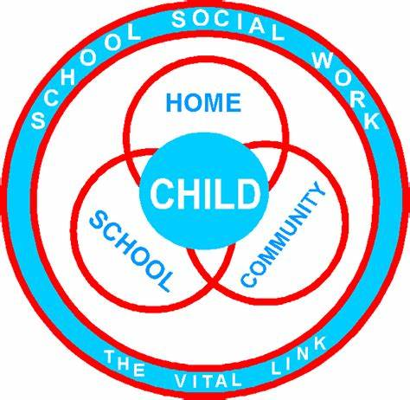

Katina Watts, MSW -School Social Worker
678-984-4106
Email: Katina_Watts@dekalbschoolsga.org
Virtual Social Work Services
8:00 a.m. – 4:00 p.m.

Serving Schools:
Region 3: Rock Chapel Elementary and Stephenson Middle School
Region 4: Stone Mountain Elementary and Stone Mill Elementary

Food Resources:
- Dekalb County School System: Please check the school districts website for a listing of food sites
- Websites/Apps: Foodfinder.us (download app and zip code in)
- Contact your SSW if you need emergency food assistance

Police Services: The DeKalb County School Resource Office is closed.
- Please contact the DeKalb Police Department for non-emergencies at678-406-7929
- All emergencies call 911.

Mental Health Services:
- DeKalb Community Service Board (CSB)- 404-892-4646- is open and providing tele- mental heath services
- Chris 180- 404-486-9034 is open and providing tele-mental health services
- Pathways- 404-378-2300 –is open and providing tele-mental health services
- Georgia Crisis and Access Line -1-800-715-422 is open and providing tele-mental health services

Utilities Assistance: Please contact your utility provider directly.
- Electric(GA Power)- will provide a 30-day wavier on bills
- Water (DeKalb County Water)- No shut off
- Gas Companies- Have not made a decision as to what they will provide

